Frances K. Staub Doll Collection

Part I: Collection description and it information objects:

  - Location of collection:

The Frances K. Staub Doll Collection is housed at the Strong Museum located at One Manhattan Square in Rochester, New York. The museum contains over 500,000 objects, including a large and historically significant doll and toy collection. The museum was founded in 1968 by Margaret Woodbury Strong to share her collections of American Life.

  - Purpose of the collection:

The users of this collection are researchers (doll enthusiasts and collectors), staff of the museum, and general museum visitors. General visitors’ main point of access to the collection is through the displays located in the galleries. All users are able to access to the collection at http://www.strongmuseum.org. The purpose of the collection is two-fold: generic use and research. General visitors to the museum, through displays, will learn about the dolls and their history. Researchers such as doll enthusiasts and collectors will use the collection to understand how the collection was put together, to gather information about the dolls, and to study the history of doll collection and the development of doll creation in the United States.

  - Physical and intellectual aspects of objects:

The physical format for the collection is dolls and their associated clothing and objects. This could include a doll, the clothes it is wearing and any object the doll is holding. It could also include an object in which the doll is associated, such as a chair, bed, doll stand or book. Some of the intellectual aspects of this collection include:
1. Type of doll
2. Creator of doll
3. History of the doll

  - Extent of collection and plans for growth:

The collection consists of over 1500 antique dolls and associated items of the dolls. The collection will not continue to grow since it was collected privately by Frances K. Staub and has now been donated to the Strong Museum after her death.

Part II: Users of the collection:

  - User group(s):

There are three distinct user groups for this collection. All three user groups will have the same access to the data in the database as it will be listed in museum displays, in online access points available throughout the museum, and via the online collection listing available at http://www.strongmuseum.org. The first user group is the museum visitor. Their use will be through museum gallery displays or via the online displays at http://www.strongmuseum.org. Their use is general in nature and will include learning about the history of the dolls from the extensive historical information provided with the collection. They will be more interested in the aesthetics of the collection such as the dolls, the clothes the dolls are wearing and the additional items that accompany the dolls. The second is the researcher, such as a doll enthusiasts or collectors. When Frances K. Staub donated the collection to the museum, she wanted doll enthusiasts and collectors to have hands-on access to this collection so they could use this collection to understand how the collection was put together, to gather information about the dolls, and to study the history of doll collection and the development of doll creation in the United States. They will also be able to access the collection via the online displays at http://www.strongmuseum.org. The last user group is the museum staff who would use the collection to be able to educate the public and assist researchers and general museum visitors who visits the museum or the web page.

  - Demographics:

The demographics for the general museum visitors who visit the Strong Museum can cover a wide range of individuals, from young to old, many different ethnicities, and all occupations. The museum is the home of the National Toy Hall of Fame and was ranked one of the Top 10 Children’s Museums in the country by Child Magazine (February 2002). The demographics for the researcher will probably range from mid 20’s and older, but will primarily be those with more disposable income to spend on antique dolls who will also be interested in learning about the types of dolls available and the history of doll creation. The demographics for the museum staff will cover a wide range of ethnicity. Most will have a high level of education, many with advanced degrees.

  - Types and levels of knowledge:

Researcher:

Domain Knowledge: The researchers of this collection will have a high level of domain knowledge. They will be interested in specific objects of the collection, either to get more information about the object or to gather information because they are looking to collect an object like the one in the collection.

System Knowledge: The researchers of this collection will also have high system knowledge. They will know exactly what they are looking for when searching the system. They will have specific needs and will know how to search for them.

Task Knowledge: The researchers of this collection will have high task knowledge. They will have specific tasks in mind when searching the collection. They will be interested in specific items in the collection and will know the terms to get the results wanted.

World Knowledge: Researchers of this collection will have high world knowledge. They will be familiar with all aspects of doll history and doll creation. Many will have visited other museums, doll shows, or antique shows to view other collections.

General Museum Visitors:

Domain Knowledge: General museum visitors will have low domain knowledge. In general they will be interested in the aesthetics of the collection.

System Knowledge: General museum visitors will also have low system knowledge. Many will have basic searching skills but if/when they search the system they will be looking for basic doll information. When using the website, which staff, researchers and general visitors will use, they will be interested in seeing the pictures of the dolls from the collection.

Task Knowledge: General museum visitors will have low task knowledge. Many will browse the collection to find interesting dolls to look at. Those that access through the website will also browse through the collection online to get to the pictures of the dolls they are interested in.

World Knowledge: General museum visitors will have low to high world knowledge. Some museum visitors will have traveled extensively while others will have not traveled outside of Rochester, New York.

Museum Staff:

Domain Knowledge: The museum staff will have a high level of domain knowledge. They will be interested in specific objects of the collection, either to get more information about the object for educational purposes or to assist in providing information to researchers.

System Knowledge: The museum staff will also have high system knowledge. They will know exactly what they are looking for when searching the system. They will have specific needs and will know how to search for them.

Task Knowledge: The museum staff will have high task knowledge. They will have specific tasks in mind when searching the collection. They will be interested in specific items in the collection and will know the terms to get the results wanted.

World Knowledge: Museum staff will have high world knowledge. They will be familiar with all aspects of doll history and doll creation. Most will have advanced degrees and will be familiar with the other collections in the museum.

  - User’s problems and questions

A.

Researchers’ will be looking for information on specific dolls, their creation, history, and other information regarding dolls in the collection. They will be interested in gathering information to increase their knowledge of dolls and specifically dolls in collections they own. General museum visitors will be looking for dolls from the collection that are interesting to look at or that have unique characteristics. They are going to be more interested in the aesthetics’ of the dolls rather than information about the creation or history of the doll. Museum staff will be using the collection to assist with the educational mission of the museum and to assist researchers and general museum visitors.

B.

User Question: I would like to find all dolls which include a book in their associated objects.
Suggested Attributes: Subject, Physical Description
Desired Precision/Recall: For this request, both precision and recall will be high. The user has a specific query and is looking for dolls that have books with them.

User Question: Can you discuss the history of the Amelia Earhart doll and its significance in the development of “theme” dolls?
Suggested Attributes: Subject
Desired Precision/Recall: For this request, precision and recall is high. The requestor is discussing one specific doll and is looking for historical information regarding this in relation to other “theme” dolls.

User Question: Can you tell me about the doll that is holding Humpty Dumpty?
Suggested Attributes: Subject, Physical description
Desired Precision/Recall: For this request, precision and recall is high. The requestor is discussing one specific doll and is looking for specific information about this doll.

Part III: System design:

  - Entity level or unit of analysis and why appropriate

For this collection, the entity level will be the individual doll. This is appropriate for this collection because each doll is unique and has its own creator, story and history. Each doll must be entered separately to make sure the correct information is presented for each doll.

  - Attributes chosen and their appropriateness to the collection

The attributes chosen to identify the objects of the collection are Physical Description, Name, Subject, Date, Classification, Notes, and Availability.

- Physical description defines and describes the doll.
- Each doll also has a Name and that is an important attribute as well. People may want to be able search by Name.
- Subject is also an important attribute because this will provide different information about the doll.
- The Date the doll was created is also an important attribute. The age of the doll can have considerable impact on its prestige.
- Notes attribute will cover any information that is not entered in the Subject attribute.
- Classification is important because it allows the users of this database to know that like objects will be intellectually located near one another, even if the museum decides to physically locate them separately.
- Finally, with knowing if the dolls are in the museum or not make Availability another important attribute.

  - Field names and indexing decisions

General Attribute | Field Name | Searchable? (Y/N)
Physical Description | Collection Name | Y
 | Accession Date | Y
 | Location in Museum | Y
 | Accession Number | Y
 | Image | N
 | Materials Used for Head | Y
 | Materials Used for Body | Y
 | Description of Head/Face | Y
 | Description of Clothes | Y
 | Height | Y
 | Maker's Mark | Y
 | Items Associated with Doll | Y
Name | Name | Y
Subject | Type of Doll | Y
 | Manufacturer | Y
 | Country of Origin | Y
 | Historical Background | Y
Date | Creation Date of Doll | Y
Notes | Additional Notes | Y
Classification | Doll Classification | Y
Availability | On Loan | Y

The fields chosen to index were ones that staff would most likely use to access dolls. However, all three user groups will have the same access to the information in the database and the ability to search for information in the database. It is the museum’s policy to make as much of the information about objects located in the museum available to staff, researchers and general museum visitors. The museum is a place for all to learn so access to all information relating to objects is available for all user groups.

Any member of all user groups may want to look for dolls that are made out of a specific material type so Materials Used for Head or Materials Used for Body are searchable. Also any member of all user groups may want to look for dolls based on descriptions of the head/face and/or clothes, so the fields Description of Head/Face and Description of Clothes will be searchable. The Name is also important to be able to search on. Each doll has a name and many will only want to search on the Name field. Manufacturer, Country of Origin and Creation Date of Doll should also be able to be searchable as users may want to be able to find dolls in one of these fields. Items associated with the doll should also be searchable. In the sample questions, one of the requests was to find out which doll is based on a book. Maker’s Mark is also important to be able to search on because researchers and/or staff may only want to find dolls with specific Maker’s Mark. Also, Historical Information and Additional Notes should be searchable because users may want to be able to search on a specific historical aspect of the doll or other information about the doll. Accession Number and Collection Name should also be searchable. If someone knows the exact Accession Number then they will be able to pull up that information right away. Finally, the Collection Name will be searchable because one should be able to search by Collection Name with respect to the larger museum collections.

At this time, there are limits to image searches. Therefore, for this collection, one will not be able to search by Image. This is specifically important for users of the Strong Museum webpage (http://www.strongmuseum.org).

Part IV: Semantics, Syntax, and Input Rules

  - Field Names and Semantics:

Field Name | Semantics
Collection Name | Information pertaining to the donor of the collection.
Accession Date | Time doll was acquired by museum.
Location in Museum | Unique information where object is placed.
Accession Number | Unique number used to identify each item in the collection.
Image | Individual picture of each doll.
Materials Used for Head | Description of what the part of the object where the mouth, face are located is made of.
Materials Used for Body | Description of what the main part of the object is made of.
Description of Head/Face | How the hair, face, eyes of the doll look/were created.
Description of Clothes | What the individual doll is wearing.
Height | Size of the doll.
Maker's Mark | Specific designs/words on doll denoting creator.
Items Associated with Doll | Additional objects linked with the object.
Name | What the doll is called.
Type of Doll | Generic description of the classification of doll.
Manufacturer | Company/person responsible for the creation of the doll.
Country of Origin | Location where doll originated.
Historical Background | Unique information about how the doll was manufactured, how it was collected, why it was collected and other significant information about the object.
Creation Date of Doll | Time period of manufacture.
Additional Notes | Additional information about the doll not included in the other fields.
Doll Classification | Identification of each object based on subject.
On Loan | Information whether the item is in the museum or elsewhere.

4.2: Record content and input rules

Field Name | Collection Name
Semantics | Information pertaining to the donor of the collection.
Chief Source of Information | Deed of Gift Form created for the collection when acquired by museum.
Input Rules | - Using the Deed Of Gift form created when the collection was acquired by the museum; enter the name exactly as it appears on the Deed of Gift form under Donor’s Name.  - See Appendix A for sample Deed of Gift Form.  - After the name type one space and then enter the term: Collection. The first letter of this word should be capitalized.  - This is a required field and must be completed.
Example | Frances K. Staub Collection
Field Name | Accession Date
Semantics | Time doll was acquired by museum.
Chief Source of Information | Accession Form created for the collection when acquired by museum.
Input Rules | - Enter the Accession Date exactly as it is listed on the Accession Form under Date.  - See Appendix B for sample Accession Form.  - This is a required field and must be completed.
Example | 2006.04.05
Field Name | Location in Museum
Semantics | Unique information where object is placed.
Chief Source of Information | Collections Inventory Form.
Input Rules | - Enter information as to the location of the object exactly as it appears on the Collections Inventory Form.  - There are six galleries available for dolls to be displayed in the museum, these are lettered A-F.  - Within each gallery, display locations are numbered using 4 digit numbers. Zeros will be used to left fill numbers.  - The letter of the gallery will be listed first followed by a period (no space) then the four digit location of the object.  - If the object is not on display then enter the term: NOD. Following this term, type one space, then a colon, then one space, and then enter from the Collections Inventory Form, the six digit alphanumeric location code where the object can be found.  - If the item is on loan enter NOD Loan.  - This is a required field and must be completed.
Example | F.0010
Field Name | Accession Number
Semantics | Unique number used to identify each item in the collection.
Chief Source of Information | Collection Inventory Form
Input Rules | - Accession number is created from three pieces of information located on the Collection Inventory Form: 3 Letter Collection Name, Item Number and Accession Date.  - Enter the information exactly as it appears on the Collection Inventory Form.  - Enter 3 Letter Collection Name followed by a period.  - Immediately after the period (no spaces) enter the item number followed by one space, a dash, then one space.  - Immediately following the space, enter the Accession Date.  - This is a required field and must be completed.
Example | FKS.0105 – 2006.04.05
Field Name | Image
Semantics | Individual picture of each doll.
Chief Source of Information | Collection Inventory Form
Input Rules | - Enter the information exactly as it appears on the Collection Inventory Form.  - All images are to be hyperlinked.  - Click on the name and the picture will be shown.  - All pictures must be of the type jpg or jpeg.  - This is a required field and must be completed.
Example | FKS010520060405.jpg  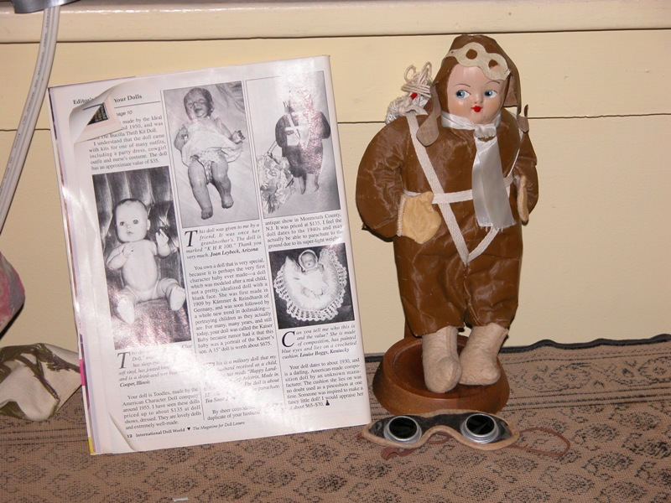
Field Name | Materials Used for Head
Semantics | Description of what the part of the object where the mouth, face are located made of.
Chief Source of Information | Doll
Input Rules | - Select from the list the material that the head is made up of.  - When entering the information there will be a drop down list containing the values available for this field.  - The list:  Cloth  Wood  Paper-Mache  Composition  China  Bisque  Parian (Untinted Bisque)  Wax  Vinyl  Hard Plastic  Celluloid  Rubber  Unknown  - This is a required field and must be completed.
Example | China
Field Name | Materials Used for Body
Semantics | Description of what the main part of the object is made of.
Chief Source of Information | Doll
Input Rules | - Select from the list the material that the body is made up of.  - When entering the information there will be a drop down list containing the values available for this field.  - The list:  Cloth  Wood  Paper-Mache  Composition  China  Bisque  Parian (Untinted Bisque)  Wax  Vinyl  Hard Plastic  Celluloid  Rubber  Unknown  - This is a required field and must be completed.
Example | China
Field Name | Description of Head/Face
Semantics | How the hair, face, eyes of the doll look/were created.
Chief Source of Information | Doll and/or Collection Inventory Form
Input Rules | - Describe information about the head/face such as the eye color, hair type and color, mouth formation.  - If information is listed on the Collection Inventory Form, enter this information from this form.  - Use sentence form when entering this information.  - After the end of a sentence, enter two spaces and then start the next sentence.  - This field is a free text field.  - This is a required field and must be completed.
Example | Doll has blue eyes with painted black hair. Lips are painted red with pursed lips. Rosy red cheeks are also painted onto the face.
Field Name | Description of Clothes
Semantics | What the individual doll is wearing.
Chief Source of Information | Doll and/or Collection Inventory Form
Input Rules | - Describe information about what the doll is wearing.  - If information is listed on the Collection Inventory Form, enter this information from this form.  - Use sentence form when entering this information.  - After the end of a sentence, enter two spaces and then start the next sentence.  - This field is a free text field.  - This is a required field and must be completed.
Example | Doll is wearing plaid jacket and long skirt. Jacket and skirt are brown/blue/tan plaid. The skirt contains red trim at bottom and about 2/3 of way down skirt. There is red trim around the collar, sleeves and bottom of jacket. Two rows of red buttons also adorn the jacket. The doll is also wearing a black hat with a red bow.
Field Name | Height
Semantics | Size of the doll.
Chief Source of Information | Doll and/or Collection Inventory Form
Input Rules | - Height of the doll will be recorded in inches only.  - Height will be recorded to the nearest inch.  - Enter only the numeric number in this field.  - This is a required field and must be completed.
Example | 14
Field Name | Maker's Mark
Semantics | Specific designs/words on doll denoting creator.
Chief Source of Information | Doll and/or Collection Inventory Form.
Input Rules | - Enter exactly as seen on doll or entered on the Collection Inventory Form.  - If information from the doll or Collection Inventory Form is capitalized, then capitalize the information in this field. If it is not capitalized, then do not capitalize.  - If no Maker’s Mark is on the doll, enter NONE.  - NONE should be entered in all capital letters.  - No punctuation should be entered after the information entered about the Maker’s Mark. or the word NONE.
Example | NONE
Field Name | Items Associated with Doll
Semantics | Additional objects linked with the object.
Chief Source of Information | Doll and/or Collection Inventory Form.
Input Rules | - Describe any items that are associated with the doll.  - If information is listed on the Collection Inventory Form, enter this information from this form.  - Use sentence form when entering this information.  - After the end of a sentence, enter two spaces and then start the next sentence.  - This field is a free text field.  - If there is no information to enter in this field, it can be left blank.
Example | This doll also has associated with it a book called The Snow Baby by Josephine D. Peary.
Field Name | Name
Semantics | What the doll is called.
Chief Source of Information | Collection Inventory Form.
Input Rules | - Enter the information exactly as it appears on the Collection Inventory Form under Name.  - No punctuation should be entered at the end of Name.  - This is a required field and must be completed.
Example | Amelia Earhart
Field Name | Type of Doll
Semantics | Generic description of the classification of doll.
Chief Source of Information | Collection Inventory Form.
Input Rules | - Enter the information exactly as it appears on the Collection Inventory Form under Type of Doll.  - No punctuation should be entered at the end of the Type of Doll.  - This is a required field and must be completed.
Example | Character Doll
Field Name | Manufacturer
Semantics | Company/person responsible for the creation of the doll.
Chief Source of Information | Collection Inventory Form.
Input Rules | - Enter the information exactly as it appears on the Collection Inventory Form under Manufacturer.  - If the Manufacturer has a shortened form for a name, such as Co. for Company, then enter this exactly as shown on the Collection Inventory Form.  - If no Manufacturer is known, then enter the term: Maker Unknown. Capitalize the first letter of each word.  - No punctuation should be entered at the end of the Manufacturer.  - This is a required field and must be completed.
Example | Knickerbocker Toy Co.
Field Name | Country of Origin
Semantics | Location where doll originated.
Chief Source of Information | Collection Inventory Form.
Input Rules | - Enter the information exactly as it appears on the Collection Inventory Form under Country  - When entering the information there will be a drop down list containing the values available for this field.  - The list:  United States  Germany  Italy  France  England  China  Other  Unknown  - Select unknown only if the Country of Origin is unknown. If the country is not one of the ones listed in the list, then select Other.  - This is a required field and must be completed.
Example | United States
Field Name | Historical Background
Semantics | Unique information about how the doll was manufactured, how it was collected, why it was collected and other significant information about the object.
Chief Source of Information | Collection Inventory Form.
Input Rules | - Describe historical information known about the doll.  - Describe information about how the doll was manufactured and why it was collected.  - If information is listed on the Collection Inventory Form, enter this information from this form.  - Use sentence form when entering this information.  - After the end of a sentence, enter two spaces and then start the next sentence.  - This field is a free text field.  - If there is no information to enter in this field, it can be left blank.
Example | This doll was designed to be part of a Historic Figures Characters line for Knickerbocker Toy Co. This doll was one of 10 created to commemorate Historic Figures. This was doll Number 5 of the series. The others in the series included: Marie Curie, Charles Lindbergh, and Teddy Roosevelt.
Field Name | Creation Date of Doll
Semantics | Time period of manufacture of the doll.
Chief Source of Information | Collection Inventory Form.
Input Rules | - Enter the information exactly as it appears on the Collection Inventory Form under Creation Date of Doll.  - If date provided is just one year, enter the year using a full year designation.  - If the date is given as a range, then enter the information as first date, one space, one dash, one space, second date.  - No punctuation should be entered at the end of the Creation Date of Doll.  - If no information on the Creation Date of Doll exists, then enter the term: ND into the field. Both the N and D should be capitalized with no space between the letters.  - This is a required field and must be completed.
Example | 1950
Field Name | Additional Notes
Semantics | Additional information about the doll not included in the other fields.
Chief Source of Information | Collection Inventory Form and/or Paperwork included with doll
Input Rules | - In this field enter information that does not fit it any of the other fields such as Historical Information or Items Associated with Doll.  - Type of information that should be included here includes information about when the item was purchased/obtained by the Donor; how much the Donor originally paid for the doll; and any additional information deemed relevant.  - Do NOT include in this field any information that can be found in other fields.  - Use sentence form when entering this information.  - After the end of a sentence, enter two spaces and then start the next sentence.  - This field is a free text field.  - If there is no information to enter in this field, it can be left blank.
Example | This doll was purchased by the donor from an estate sale in 1978. The donor paid $15 for the doll.
Field Name | Doll Classification
Semantics | Identification of each object based on subject.
Chief Source of Information | Classification Thesaurus
Input Rules | - Using the Classification Thesaurus, follow the rules listed below.  - The Classification Thesaurus can be found in Appendix D.  - Materials Used for Head  - From the Materials Used for Head field, select the number of the Foci that matches the information in that field.  - Enter HD followed by the number of the Foci.  - The letters H and D must be capitalized.  - No spaces between HD and the number.  - Then type a colon. No space after the colon.  - Materials Used for Body  - From the Materials Used for Body field, select the number of the Foci that matches the information in that field.  - Enter BD followed by the number of the Foci.  - The letters B and D must be capitalized.  - No spaces between BD and the number.  - Then type a colon. No space after the colon.  - Country of Origin  - From the Country of Origin field, select the number of the Foci that matches the information in that field.  - Enter CO followed by the number of the Foci.  - The letters C and O must be capitalized.  - No spaces between CO and the number.  - Then type a colon. No space after the colon.  - Creation Date of Doll  - From the Creation Date of Doll field, select the number of the Foci that matches the information in that field.  - Enter DT followed by the number of the Foci.  - The letters D and T must be capitalized.  - No spaces between DT and the number.  - Then type a colon. No space after the colon.  - Accession Number  - From the Access Number Field, type in the information in this field exactly as entered.  - There should be no space between the colon after the DT foci and the Accession Number.  - No punctuation at the end of this sequence.  - This is a required field and must be completed.
Example | HD1:BD4:CO7:DT7:FKS.0105 – 2006.04.05
Field Name | On Loan
Semantics | Information whether the item is in the museum or elsewhere.
Chief Source of Information | Collections Inventory Form
Input Rules | - Enter information exactly as it is listed on the Collections Inventory Form.  - If the item is not on loan, enter the information from the field Location in Museum.  - This is a free text field which may include the place where the item is on loan and the length of time the item will be on loan.  - Use sentence form when entering this information.  - After the end of a sentence, enter two spaces and then start the next sentence.  - This is a required field and must be completed.
Example | F.0010

Part V: Records for your objects

Object 1
Field Name | Values
Collection Name | Frances K. Staub Collection
Accession Date | 2006.04.05
Location in Museum | F.0010
Accession Number | FKS.0105 – 2006.04.05
Image | FKS010520060405.jpg
Materials used for head | Bisque
Materials used for body | Cloth
Description of Head/Face | The doll has blue-gray eyes shifted to the right. The doll has red painted lips on a closed mouth. The doll also has painted on eyebrows.
Description of Clothes | The doll is wearing a brown one-piece flight suit. The doll also has a flight hat on with goggles. The doll is also wearing gloves on the hands. The doll also has a satin scarf around its neck. The doll also is wearing a parachute with white ribbon criss-crossing the body. No shoes are on the doll.
Height | 15
Maker's Mark | NONE
Items associated with doll | The doll also has child-size goggles with it. The goggles have a rubber band-like strap to hold them on the head. The doll also has the magazine International Doll World with it showing the doll.
Name | Amelia Earhart
Type of doll | Character Doll
Manufacturer | Knickerbocker Toy Co.
Country of Origin | United States
Historical Background | This doll was designed to be part of a Historic Figures Characters line for Knickerbocker Toy Co. This doll was one of 10 created to commemorate Historic Firsts. This was doll Number 5 of the series. The others in the series included: Marie Curie, Charles Lindbergh, and Teddy Roosevelt.
Creation Date of Doll | 1950
Additional Notes | This doll was purchased by the donor from an estate sale in 1978. The donor paid $15 for the doll.
Doll Classification | HD1:BD4:CO7:DT7:FKS.0105 – 2006.04.05
On Loan | F.0010
Object 2
Field Name | Values
Collection Name | Frances K. Staub Collection
Accession Date | 2006.04.05
Location in Museum | A.1254
Accession Number | FKS.0589 - 2006.04.05
Image | FKS058920060405.jpg  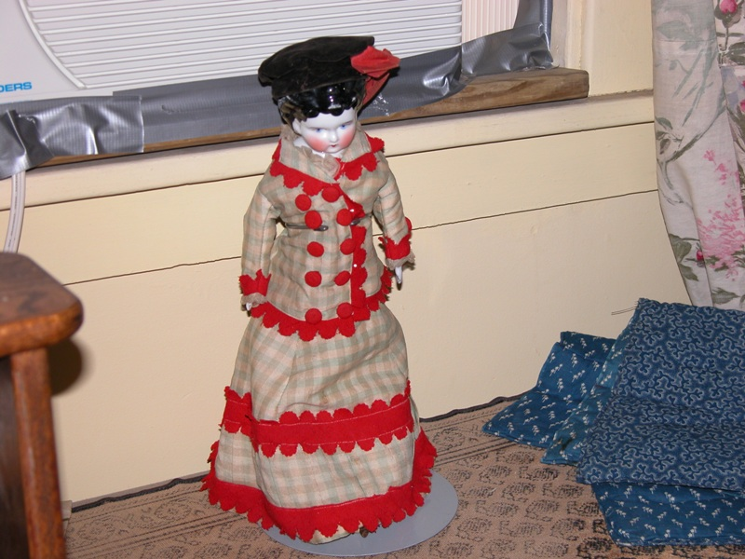
Materials used for head | China
Materials used for body | China
Description of Head/Face | Doll has blue eyes with painted black hair. Lips are painted red with closed lips. Rosy red cheeks are also painted onto the face.
Description of Clothes | Doll is wearing plaid jacket and long skirt. Jacket and skirt are brown/blue/tan plaid. The skirt contains red trim at bottom and about 2/3 of way down skirt. There is red trim around the collar, sleeves and bottom of jacket. Two rows of red buttons also adorn the jacket. The doll is also wearing a black hat with a red bow.
Height | 14
Maker's Mark | 5 a & 11
Items associated with doll
Name | Millie
Type of doll | Visiting Doll
Manufacturer | Maker Unknown
Country of Origin | Germany
Historical Background | The doll is a typical of a German visiting doll and has its original clothes.
Creation Date of Doll | 1862 - 1875
Additional Notes | This doll was received as a gift by the donor in 1990.
Doll Classification | HD3:BD3:CO4:DT6:FKS.0589 - 2006.04.05
On Loan | A.1254
Object 3
Field Name | Values
Collection Name | Frances K. Staub Collection
Accession Date | 2006.04.05
Location in Museum | NOD : 695112
Accession Number | FKS.0001 - 2006.04.05
Image | FKS000120060405.jpg  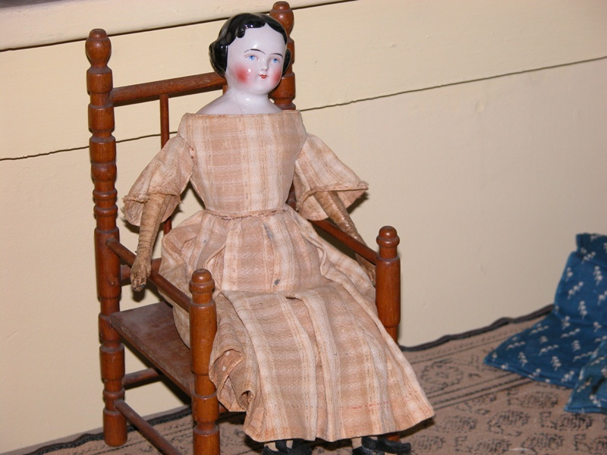
Materials used for head | China
Materials used for body | Cloth
Description of Head/Face | Doll has blue eyes with painted black hair. Lips are painted red with pursed lips. Rosy red cheeks are also painted onto the face.
Description of Clothes | The doll is wearing a plain brown plaid dress with a cinched waist. The sleeves on the doll are 3/4 length. The doll has gloves that are attached to the cloth body.
Height | 12
Maker's Mark | PAR BREVET
Items associated with doll | A wooden chair that the doll sits in. The chair is made out of wood and has an open back.
Name | Marie'
Type of doll | China-head doll
Manufacturer | Jacob Petit
Country of Origin | France
Historical Background | The doll was created by Jacob Petit who made the china heads for the dolls instead of getting them from another manufacturer. The dolls gloves that are attached to the cloth body are typical of this type of doll.
Creation Date of Doll | 1840 - 1860
Additional Notes | This doll was purchased at an antique store for $100 in 1992. The chair did not come with it and was made donor.
Doll Classification | HD3:BD4:CO3:DT6:FKS.0001 - 2006.04.05
On Loan | NOD : 695112
Object 4
Field Name | Values
Collection Name | Frances K. Staub Collection
Accession Date | 2006.04.05
Location in Museum | B.3564
Accession Number | FKS.1234 - 2006.04.05
Image | FKS123420060405.jpg  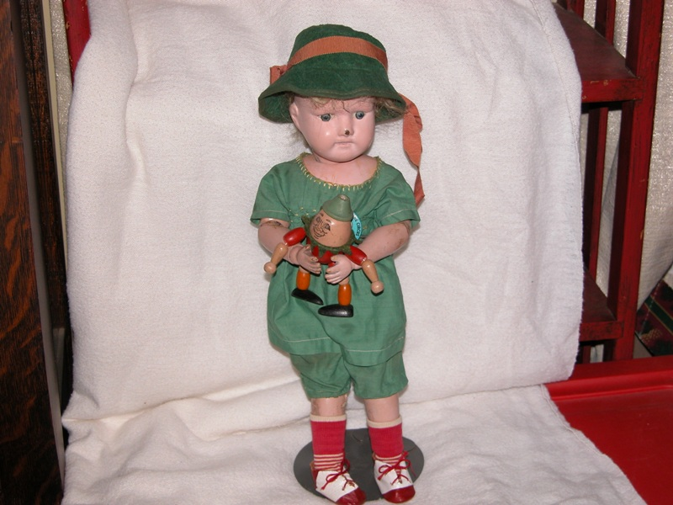
Materials used for head | Bisque
Materials used for body | Bisque
Description of Head/Face | The doll has gray eyes that are facing forward. The mouth is closed. The hair is fake human hair and is blond and is attached to the head through the scalp. A piece of the nose has broken off.
Description of Clothes | The doll is wearing a green short set. The top is short sleeve with rounded color. There is yellow trim around the color. The shorts are also green and come to just below the knee. The doll is wearing red and white striped socks and red and white tie shoes. The doll is wearing a green cloth hat with a tan ribbon encircling the top of the hat.
Height | 11
Maker's Mark | NONE
Items associated with doll | The doll is holding a wooden "Humpty Dumpty" doll. The "Humpty Dumpty" doll has a painted face and the clothes are also painted on. The "Humpty Dumpty" doll has a green pointed hat attached to the head.
Name | Susie Q
Type of doll | Girl doll with toy
Manufacturer | Madame Alexander
Country of Origin | Unknown
Historical Background | This doll was one created for children during the 1920’s that were used to tell Fairy Tales.
Creation Date of Doll | 1925
Additional Notes | The clothes for the doll were made by the donor. The doll originally clothes of the same type but were in very poor condition. The hat is original to the doll.
Doll Classification | HD1:BD1:CO:8:DT7:FKS.1234 - 2006.04.05
On Loan | B.3564
Object 5
Field Name | Values
Collection Name | Frances K. Staub Collection
Accession Date | 2006.04.05
Location in Museum | NOD Loan
Accession Number | FKS.1057 - 2006.04.05
Image | FKS105720060405.jpg  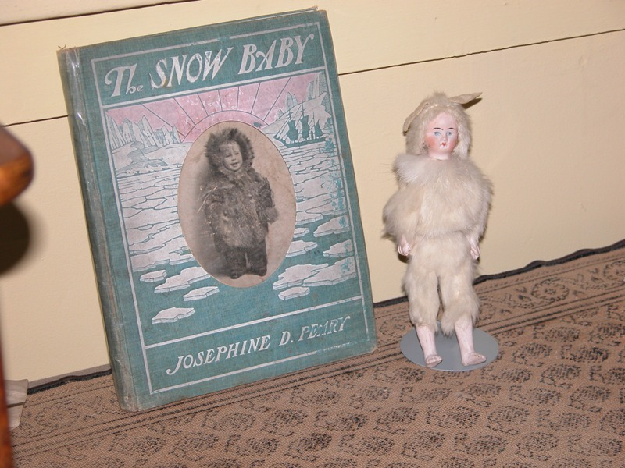
Materials used for head | Composition
Materials used for body | Wood
Description of Head/Face | The doll has blue eyes. Lips are painted red with closed lips. Rosy red cheeks are also painted onto the face.
Description of Clothes | The doll is wearing a two piece fake fur coat and pants. They are both an off-white color. The pants go about 2/3 of the way down the leg. The doll is not wearing any gloves or shoes. The doll also has a fake fur hat on its head with "floppy" rabbit ears attached.
Height | 10
Maker's Mark | NONE
Items associated with doll | This doll also has associated with it a book called The Snow Baby by Josephine D. Peary.
Name | Snow Baby
Type of doll | Book Doll
Manufacturer | McDonald of Canada
Country of Origin | Other
Historical Background | This doll was created to capture the interest girls had in the story The Snow Baby.
Creation Date of Doll | 1921
Additional Notes | The donor purchased the doll and book separately and then placed them together. The doll cost $50 in 1970 and the book cost $75 in 1990.
Doll Classification | HD5:BD12:CO6:DT7:FKS.1057 - 2006.04.05
On Loan | This doll is on loan to the Sheldon Jackson Museum in Sitka Alaska until June 2008.

Part VI: Project summary

In the beginning I decided I wanted to organize these dolls as a way to remember my grandmother. She always loved dolls and she would share what she knew about the dolls with me. Unfortunately, what we have now are the dolls, pictures of the dolls and not much more information. This was my way of thinking about how we would want to organize the doll collection that has now been passed down to my mother. I used the collection to be hypothetically housed in the Strong Museum because to me that is the ultimate doll museum, at least in Rochester.

For this project, I consulted The Knopf Collector’s Guides to American Antiquities: Dolls for the information that seemed to be important to doll collectors. Most of my descriptive fields for this organization project came directly from the information included in this book for important characteristics dolls. Even though this book is designed for the collector, it seemed to be information that a museum would probably be interested in having in their collection information.

I believe that my project came out exceptionally well. It was a little daunting because I had so many fields to deal with. When I was creating the input rules for the 21 fields, I thought I would never get done. It was also hard to create the input rules because much of the information would be from any paperwork that was associated with the doll. This is why I created the Collection Inventory Form. I felt that a controlled form was needed that the museum would have for each object. It would be unlikely they would take handwritten notes and other information from a donor without creating a form for each item. Yes, it is a duplication of information on the form and in the database created but I envisioned the Collection Inventory Form to be the form for the cataloger to fill out when the item first arrives.

There were a couple areas that I had trouble with. At first I wanted to be able to have images for the Maker’s Mark but then I realized that people may want to be able to search on a particular Maker’s Mark, so I used the convention that was in the book The Knopf Collector’s Guides to American Antiquities: Dolls and just typed in the information on the doll. If I was actually designing this, I would create the opportunity to have both an image of the Maker’s Mark and the actual text of the Maker’s Mark. The other area I had trouble with was the Image of the doll. I wanted to be able to put in the name of the file and the ability to see the actual doll. In the end, I am not sure if it should have been two separate fields. Most likely in practice, if the database was created, the picture would be at the top of the screen and the information about the doll would be below, including the file name for the Image of the doll.

Someone had mentioned in class if it was alright to create the information and then go back and write the rules. I did this for some of the fields. It was easier to look at how the Accession Number and the Doll Classification would look and then go back and write the rules for it.

Another area that I found difficult was the free text fields. It is easy to state to write in sentence structure but then as I was typing I noticed I put two spaced between each sentence. I realized that not everyone may do this, so I had to go back and update my input rules to reflect this. I also had to go back to other fields and update the rules with information that I was missing. I realized for the location in the museum, I had not offered an option for dolls that were not on display but were in the storage area. I also had not taken into account the option for On Loan. I had envisioned the On Loan field to provide information about where the object was and how long it would be out of the museum, so I realized I also needed to add an option for not on display because it was on loan.

I definitely learned the need to control and very specifically note how everything will be entered into a database, particularly when more than one person may use the database. I have created databases previously for my work and I knew how I wanted the information to be input, but I really had never thought about how others would enter this same information into the database since I did not provide exactly how each field should be formatted. This project has also allowed me to see more clearly the differences in input format that are inherent when more than one person is involved. I work at the circulation desk at the Brighton Memorial Library in Rochester, and each library seems to catalog items just a little bit differently, with regards to title and series, so I can see where input rules would help immensely in searching for items when I need to find an item because the barcode has fallen off.

Finally, I found the classification field to be the most difficult. It was difficult to try to represent the object so that someone could search and find related objects. I finally made the decision to choose Materials Used for Head, Materials Used for Body, Country of Origin, and Creation Date of Doll for the facets of this collection. One change I made was that I instead of individual dates, for the classification I chose to use century markers as general dates for dolls from 16th through 21st century. Since this collection was mostly dolls from the 19th and 20th centuries, I could have just used those as facets but I thought that this could be used for any collection in the museum, so I added additional Creation Date loci. If I had to do it over again, I would still choose the same foci for the faceted system because from my review of The Knopf Collector’s Guides to American Antiquities: Dolls, it seems that the materials the dolls are made of are one of the most important aspects of the doll.

Reference:
Lavitt, W. (1983). The Knopf Collector’s Guides to American Antiquities: Dolls. New York: Alfred A. Knopf.

Appendix A

Deed of Gift

Donor’s Name: ____________________________________________
Address:_________________________________________________
Phone: ______________________________________

I (we) hereby irrevocably and unconditionally give, donate, deliver, transfer, and assign to the ____________________ Museum by way of gift all right, title, and interests (including, but not limited to, all applicable copyright, trademark, and related interests) in, to, and associated with the property, hereinafter described, to be used by the Museum at its unrestricted discretion. I (we) affirm that I (we) own said property and that to the best of my (our) knowledge I (we) have good and complete right, title, and interest (including, but not limited to, all applicable copyright, trademark, related interests) to give.

I (we) agree that the object(s) will become part of the exclusive and absolute property of the Museum and that it (they) may be managed in any ethical manner consistent with established professional standards, Museum policy, and governmental regulations, with no restrictions on its (their) use or disposition.

Donor’s Signature: ____________________________
Date: ________________________________
received for the ______________________________Museum
by Curator’s Signature: ________________________
Date: ________________________________
Approved by Museum Director: _______________________________________________________

Deed of Gift
Everyday Language Translation
By signing this, I give and deliver my object forever and with no conditions to the Museum. I give the museum all rights to the object. These rights include the right to publish pictures of it for sale or use. I also say that I did own the object and had the right to give it to the museum.

I agree that the object will become the property of only the Museum. The Museum will manage it in an ethical, professional way. The Museum can use it or dispose (trade or give it away) of it in any way they want, following the Museum’s policies.

From: http://www.museum.state.il.us/muslink/pdfs/forms.pdf accessed June 24, 2006.
Appendix B
Strong Museum
One Manhattan Square, Rochester, NY 14609
585-263-2700
ACCESSION RECORD
Collection Name:______________ |  | Date:___ ________
Date received:____ __________
Received from:__ ______________________________
Address and telephone:________________________________________
_____________________________________________________
Accession Title:__ Collection__________________________
Contents:
__ Textual records | _ _ Dolls |  |  | __ Toys
__ Photographs
__ Prints, Paintings, Drawings |  |  |  | __ Film/video
__ Other (describe)___________________________________________
Extent:
Description:_________________________________________________
Acquisition information:
_X_ Donation |  | __ Transfer
__ Other
Notes:___________________________________________
Date acknowledged: ________________________________________
Curator:__________________________________________________

Form created from sample accessed June 24, 2006 from http://aabc.bc.ca/aabc/msa/3_sample_accession_record.htm
Appendix C

Strong Museum
One Manhattan Square, Rochester, NY 14609
585-263-2700

COLLECTIONS INVENTORY FORM

3 Letter Collection Name
Item Number
Accession Date
Location in Museum
Description of Doll
Maker’s Mark
Name
Type of Doll
Manufacturer
Country of Origin
Creation Date
Items Associated with Doll

Historical Information
Picture Name

Completed By: | Date:

Appendix D

 | HD | BD | CO | DT
Foci | Materials Used for Head | Materials Used for Body | Country of Origin | Creation Date of Doll
1 | Bisque | Bisque | China | Prior to 1000 A.D.
2 | Celluloid | Celluloid | England | 1000-1400 A.D.
3 | China | China | France | 16th Century
4 | Cloth | Cloth | Germany | 17th Century
5 | Composition | Composition | Italy | 18th Century
6 | Hard Plastic | Hard Plastic | Other | 19th Century
7 | Paper-Mache | Paper-Mache | United States | 20th Century
8 | Parian (Untinted Bisque) | Parian (Untinted Bisque) | Unknown | 21st Century
9 | Rubber | Rubber |  | Unknown
10 | Vinyl | Vinyl
11 | Wax | Wax
12 | Wood | Wood
13 | Unknown | Unknown

Rules:
Note—each letter code is required for this classification scheme. Each facet allows for unknown information.

- Materials Used for Head
- From the Materials Used for Head field, select the number of the Foci that matches the information in that field.
- Enter HD followed by the number of the Foci.
- The letters H and D must be capitalized.
- No spaces between HD and the number.
- Then type a colon.

  - Materials Used for Body
- From the Materials Used for Body field, select the number of the Foci that matches the information in that field.
- Enter BD followed by the number of the Foci.
- The letters B and D must be capitalized.
- No spaces between BD and the number.
- Then type a colon.

  - Country of Origin
- From the Country of Origin field, select the number of the Foci that matches the information in that field.
- Enter CO followed by the number of the Foci.
- The letters C and O must be capitalized.
- No spaces between CO and the number.
- Then type a colon.

  - Creation Date of Doll
- From the Creation Date of Doll field, select the number of the Foci that matches the information in that field.
- Enter DT followed by the number of the Foci.
- The letters D and T must be capitalized.
- No spaces between DT and the number.
- Then type a colon.

  - Accession Number
- From the Access Number Field, type in the information in this field exactly as entered.
- No punctuation at the end of this sequence.

Sample Example:

- Materials Used for Head
China = HD3

  - Materials Used for Body
Cloth = BD4

  - Country of Origin
United States = CO7

  - Creation Date of Doll
20th century=DT7

  - Accession Number
FKS.0105 – 2006.04.05

Sample record: HD3:BD4:CO7:DT7:FKS.0105 – 2006.04.05

