Mysteries of Harris Burdick
By Chris Van Allsburg

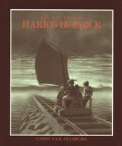
Contest Guidelines

- You must be a grade 6 student at Lowville Academy Middle School.
- All ideas must be original.
- All entries must have a title.
- Your entry must be your own creative work.
- You may have a classmate help you revise or edit.
- Characters can not engage in inappropriate actions that contain violence (example: killings, violent weapons, etc.).
- Headers must be on the back of the story—NOT THE FRONT—so that your entry can be judged fairly.
- All entries must be typed according to our typing guidelines (see web page).
- All entries must be submitted by _____________________.
- Sign the contest rules stating that you followed the guidelines and hand it in with your story.

Note: Failure to follow the guidelines will result in disqualification from the contest.

The entry for “The Mysteries of Harris Burdick Writing Contest” is my original work. I followed all the guidelines stated above.

______________________ _______________
(Student Signature) (Date)

