“Beowulf” Vocabulary

Directions: On a separate sheet of paper, WRITE a sentence using each word on the list. You may change the form of a word so that it is used correctly. Circle the vocabulary word in each sentence. You may use two vocabulary words in one sentence. Details from “Beowulf” can be used to create sentences, but you cannot copy sentences from the story. Staple your paper to this sheet.

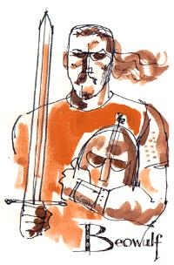
- pledge (n): a promise or oath
- ravage (v): to damage or destroy
- reigned (v) : to rule or be in power
- undaunted (adj): fearless, not concerned
- carnage (n): killing or bloodshed
- stronghold (n): place that provides protection
- valiant (adj): courageous, brave
- odious (adj): worthy of being hated
- valiant: brave or courageous
- immense (adj): enormous, huge
- perilous (adj): dangerous, risky, hazardous
- onslaughts (n): attacks or assaults
- valor (n): courage
- carnage: killing and bloodshed

loathsome (adj): hateful, disgusting

5 Point Bonus: On plain white paper, draw a picture of a character from Beowulf.

