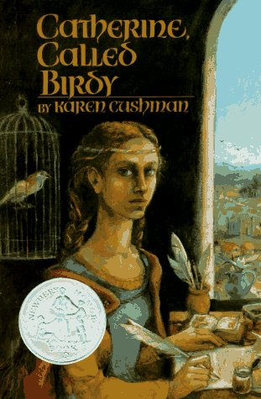
Book Review Project
Catherine Called Birdy
by Karen Cushman

How to Write a Book Review
- Read what other students have written about this book.
- Go to the scholastic website, “Write a Book Review with Rodman Philbrick,” http://teacher.scholastic.com/writewit/bookrev/index.htm.

- Complete steps 1-4 of the tutorial with Rodman Philbrick.

- Type your book review in Microsoft Word.

- After completing step 4 and writing your review, print your book review and give it to the teacher for feedback.

- You must be in my classroom for the final step: After making the necessary corrections, copy and paste your book review into the submission form on the “Scholastic What You’re Reading” web site, http://teacher.scholastic.com/activities/swyar/write.asp. DO NOT PUBLISH until you have the teacher’s permission to do so.

Click here for a printable copy of this handout

