QARs

Question Answer Relationships

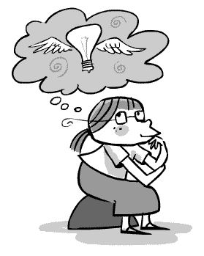
In Your Head
Answers drawn from the author and your experiences

In the Text
Answers are found in the text
Author and Me
Answer is in linking what you know to what you learned in the text
On My Own (HOT)
Answer based on your knowledge and experiences
Right There
Answer usually found in the text
Here and There
Answer is in more than one place in the text
Usually the answer and the question are word for word.
- Simple List
- Description
- Explanation
- Sequence

- Text to Self
- Text to Text
- Text to World

Answers require higher order of thinking and are not found in the text

