AP Physics Lab Brockport High School NY USA
Effective Force Constants of Harmonic Oscillators Mr Keefer

Introduction
Simple harmonic motion (SHM) occurs when an oscillating body has an applied force that obeys Hooke=s Law (F = -kx), and no non-conservative forces such as friction act to dampen the motion. The potential energy stored in a stretched or compressed spring can be determined by U_{s} = ½kx². Recalling the Work-Energy Theorem, the velocity of an oscillating body at a position in its cycle can be determined as follows:

$$\frac{1}{2}kA^{2}\text{ = }\frac{1}{2}mv^{2}\text{ + }\frac{1}{2}kx^{2}$$
(Equation 1)

where A is the amplitude of the motion and x is the position of the body from the equilibrium position. It becomes obvious that maximum velocity occurs when x = 0 and thus:

$$\text{v = }±\text{ A }\sqrt{\frac{k}{m}}$$
(Equation 2)

For a mass attached to a spring, the theoretical period (T) of oscillation is given by

(Equation 3)
$$\text{T = 2}π\sqrt{\frac{m}{k}}$$
If the period of oscillation can be measured, then the spring constant can be determined.
The objectives of this lab are (1) to determine the effective force constants (k) of several identical springs connected in various ways by measuring the maximum velocity and period (T) of an object attached to these springs, and (2) examine how amplitude affects velocity and period (T) in harmonic motion.

Materials
air track, several springs, glider, masses, photogate timer

Procedure
1. Mass the glider, then tilt the air track approximately 15-30º.

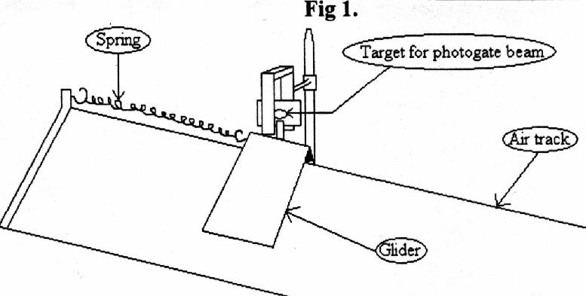
One Spring
2. Attach the end of one spring to the screw at the top of the air track and the other end to the glider.
3. Measure the length of the card attached to the glider.
4. Turn on the air track blower. Record the equilibrium position of the glider, then set the photogate such that the beam passes through the center of the card at the equilibrium position. Set the photogate switch to gate.
5. Extend the glider 10.0 cm. Release the glider and record the time for one pass through the photogate.
6. Repeat step five, except record the time for one oscillation by setting the photogate to the pendulum mode.
7. Repeat Steps 5 and 6 for four other spring extensions of between 10 and 25 cm.

Two Springs in Series
8. Attach two springs in series and with the photogate in pendulum mode, record the period of oscillation (T) for the above extensions.
Two Springs in Parallel
9. Attach two springs in parallel and record the period (T), except use extensions of 5.0 cm, 10.0cm, and 15.0cm
10. Attach two springs, one at each end of the glider, and record T at various extensions.

Analysis
1. Using your data, calculate the velocities of the glider for the one spring setup.
2. Plot a graph of velocity vs amplitude for the one spring arrangement and calculate the slope. What is the significance of the slope of the line.
3. Using the maximum amplitudes for the springs in series and parallel, calculate the effective force constants for each spring arrangement using Equation 3.
4. For the springs in series, verify that the effective force constant adheres to the equation:

$$k_{\text{eff}}\text{ = }\frac{k_{1}k_{2}}{k_{1}\text{+ }k_{2}}$$

5. Describe the effective force constant for the springs arranged at each end of the glider. Is it series or parallel in nature? Explain your answer. Propose an equation for finding k for parallel springs.

