AP Physics Lab Brockport High School NY USA
Experimental Determination of Absolute Zero Mr Keefer

Introduction
Under most conditions of constant pressure, Charles's Law states that the volume of a gas is proportional to the absolute temperature of the gas. Thus, as the average kinetic energy of the gas molecules approaches zero, the volume of the gas also approaches zero. However, real gases liquefy at various temperatures as they approach absolute zero because of van der Waals forces, and they occupy a specific volume, thus acting radically different from ideal gases.
In this experiment a volume of air is cooled and a graph of the temperature and volume relationship is plotted. From an extrapolation of the graph to zero volume, the temperature, in degrees Celsius, at which the average kinetic energy of the air molecules is zero can be predicted. This temperature is absolute zero, or 0 K.

Materials

125 mL Erlenmeyer flask 500 mL beaker or larger solid glass rod
one-hole stopper goggles large bucket
hot plate, pot holders graduated cylinder tongs
ice or snow clamps thermometer

Procedures:
(Goggles required beyond this point!)
1. Prepare an ice bath using a large bucket approximately ¾ full.
2. Fit the dry Erlenmeyer flask with a one-hole stopper.
3. Prepare a hot water bath on the hot plate in a 500 mL beaker.
4. Clamp the Erlenmeyer flask in the hot water bath such that most of the flask is under water.
5. Allow the water to boil 5 min to allow the air inside the flask to reach the temperature of the water bath.
6. Record the temperature of the boiling water to 0.1º C.
7. Place the solid glass rod into the one hole stopper, then remove the Erlenmeyer flask from the beaker. Allow it to cool for a few minutes, or until it’s comfortable to handle.
8. Invert the Erlenmeyer flask and place it in either the ice or room temperature bath. Remove the glass rod while the flask is inverted under water, then totally submerge the inverted flask for 5-6 min.
9. Stir occasionally. Record the temperature of the ice bath to 0.1º C just prior to removing the Erlenmeyer flask.

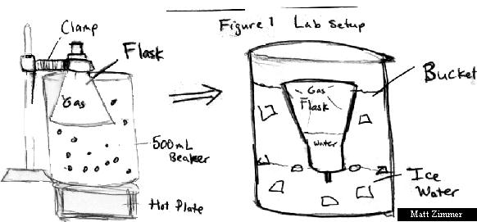

The next step should be done as quickly as possible to avoid warming of the flask.

10. Using your finger tips, raise the inverted flask until the water level inside and outside are equal. Now seal the inverted flask with the glass rod.
11. Determine the volume of water collected in the inverted flask, then the volume of the entire flask. This will allow you to calculate the volume of the air at both temperatures.

Analysis
1. Using Excel, plot the volume of the air in the flask vs. temperature. Allow room on your graph to extrapolate back to zero volume. What is your value for absolute zero? What is your percent error?
2. In your analysis, respond to the following questions:
a) why did the water flow into the flask in the ice bath?
b) why was it necessary to allow the two water levels to become equal in Step 10?
c) from your graph, what is the predicted temperature for zero volume of a gas. Calculate a % error.
d) explain why the temperature cannot drop below absolute zero.
e) what can be done to improve the accuracy of this experiment?
f) what happens to air before it gets close to absolute zero that would prevent an accurate determination of absolute zero?
g) Look up, write out, and identify the terms in the van der Waals Equation. What does this equation adjust for when dealing with real gases?
h) theoretically, what happens to molecules at absolute zero?
i) How would pressure changes alter your results?
j) What is the zeroth law of thermodynamics?
3. How many moles of gas were present in the hot water bath and the cold bath?

