Momentum Problems Brockport High School NY USA
Physics Mr Keefer
Show all work, including a sketch, equations, and units.

Momentum p = mv
1. Calculate the momentum of a 1200 kg automobile with a velocity of 25 m/s.
2. What is the momentum of a toy dart gun of mass 35 grams and a velocity of 4 m/s.
3. What is the momentum of a Boeing 737 at take off velocity (65 m/s) with a
mass of 145000 kg.

Impulse J = Ft = mΔv
4. A student driver steps on the gas pedal of an 1100 kg automobile applying a force of 600 N for 5 seconds. Determine the impulse and change in velocity of the auto.
5. The Space Shuttle crew makes a course correction in space by firing a small rocket for 10 seconds at 5000 N. The Space Shuttle has an orbital mass of 105,000 kg. What impulse was applied during the course correction and what was the change in velocity?

6. An automobile traveling at 18 m/s and with a mass of 1400 kg is stopped in 8.0 seconds. Determine the average force was applied?
7. The Space Shuttle has three LOX/Hydrogen engines for liftoff, each with a thrust of 1668 kN and a burn time of 520 seconds. What total impulse can be delivered during a launch?
8. Suggest a way to determine the impulse from the graph.

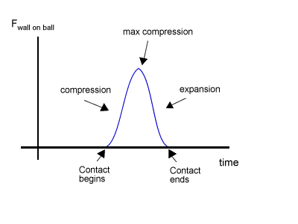

9. Estimate the impulse delivered by an Estes model rocket engine as shown on the graph.

10. Based on this impulse graph, determine the following for a 0.25 kg Estes rocket.
a) maximum thrust
b) maximum acceleration
c) average acceleration
d) total impulse (J)
e) change in velocity during the burn of the propellant

Conservation of Momentum m₁v₁ + m₂v₂ = m₁v₁ ₊ m₂v₂ or = (m₁ + m₂)v_{f}
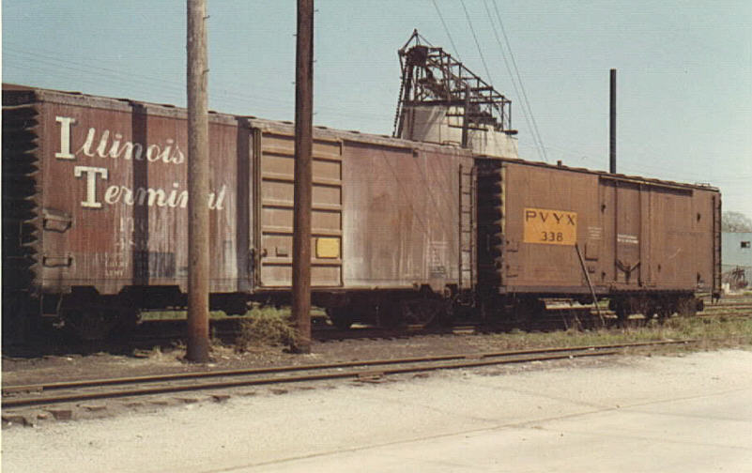
11. A 12000 kg railroad car is traveling at 2 m/s when it strikes another railroad car at rest with a mass of 10000 kg. If the cars lock together, what is the final speed of the railroad cars?
12. A 9300 kg railroad car traveling at a speed of 15 m/s strikes a second boxcar at rest. The two cars stick together and move off with a speed of 6.0 m/s. What is the mass of the second car?
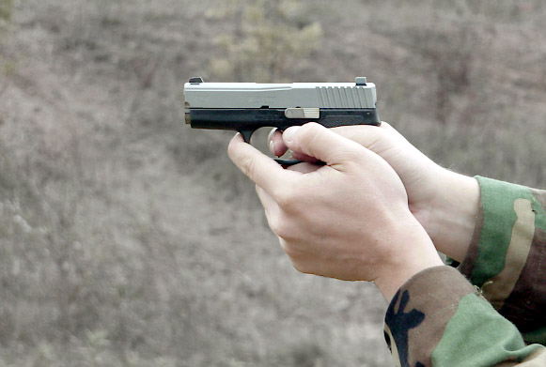
13. A 25 gram bullet is fired from a gun with a speed of 230 m/s. If the gun has a mass of 0.90 kg, what is the recoil velocity of the gun?
14. A 20 gram bullet traveling at 250 m/s penetrates a 2.0 kg block of wood and emerges cleanly at 170 m/s. If the block of wood is originally at rest, how fast does it move after the bullet emerges?

