Alphabet of the Ants
James W Keefer
Brockport High School
Brockport NY 14420-2296 USA

I. Introduction
Ants are most commonly thought of as diminutive pests. Their most remarkable biological and chemical attributes are often eclipsed by their pervasive human annoyance. One millionth the size of humans, there could well be ten thousand trillion (10¹⁶) ants trampling the earth. Estimates suggest that the mass of all the ants on our planet easily exceeds that of humans, and that one third of the biomass in the Brazilian rain forest is attributable to ants.
Approximately 9500 species of ants are known to science, some dating back well over one hundred million years into the Cretaceous Period. In the tropics, myrmecologists (ant scientists) can handily collect 300 species within 10 hectares (25 acres), and 40 or more species can inhabit a single tree. The discovery of new ant species is inevitable as exploration of the tropics expands. Most recent predictions exceed 20,000 species.
Ants are the consummate predators of insects and spiders, and many are expert grazers on leaf material. Some, such as leaf-cutters, can sustain themselves on gardens of fungi. In the process, ants recycle the nutrients of the earth, turning more soil on a daily basis than the ubiquitous earthworm.

II. Biology of the Ants
Ants are arthropods, and along with the bees and wasps, are members of the Order Hymenoptera, a word derived from their membrane-like wings. Only the alates, reproductive male and female ants, have wings that are shed promptly after mating.
The evolutionary success of ants can be partially attributed to the same reason humans have dominated the earth; they are social creatures. In a typical colony, almost exclusively female, adults care for the young, a queen acts as the Head of State, and a regimented division of labor predetermines the chores that maintain the community.
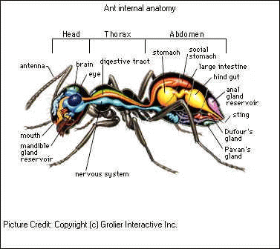
As in humans, sociality requires communication, and the ants have mastered an odorous alphabet that allows for recognition, alarm, territoriality, and internal balance of the colony. The letters of the alphabet are called pheromones and they help spell out the immediate and long term activities needed to govern the nest.

III. Glands

With a mass of less than 5 mg, an ant's anatomical structure beautifully blends form with function. It resembles a gasoline truck with several compartments, each topped off with a mixture of volatile pheromones. Most ant colonies collectively contain 10 to 20 different pheromones in their repertoire, usually with minute individual amounts totaling 10⁻⁶ to 10⁻⁹ grams. Although sometimes modified by touch or sound, pheromones are the premiere means of communication among ants. In the exemplary Citronella ant, the Dufour's Gland contains several pheromones (the usually rule) including undecane for eliciting an alarm response. For self-defense, such formidable compounds as tridecane, 2-tridecanone, pentadecane, and 2-pentadecanone are used.

IV. Features of Pheromones
When a pheromone is released from a gland, the purpose may be to elicit a response over a short distance to a few individuals, or to thousands of members throughout the colony. Pheromone vapors follow Graham's Law of Effusion and can act quickly, slowly, briefly, or have long lasting effects. The three dimensional region where pheromone concentrations trigger a behavioral response is known as the active space. The quantity of pheromone released depends upon its chemical nature and the degree of response intended by the individual informer.
To help describe the effects of pheromones, myrmecologists refer to the Q/K ratio where Q is the quantity of pheromone released and K is the threshold concentration that provokes a response. Q has units of molecules/second and K has units of molecules/cm³. Thus the Q/K ratio yields units of cm³/s and is an indicator of the rate of information transfer, analogous to a typist's words per minute Thus, the conveyance of signals triggering a response can be manipulated by adjusting Q or K values. Expanding the active space could theoretically be accomplished by raising Q values and decreasing K values. Ants have chosen the latter evolutionary path in most cases for two basic reasons. Decreasing K, the threshold level, is energetically more efficient because pheromone synthesis can be minimized, and storage glands can be kept small.
A good example of this frugality is the alarm pheromone, 4 methyl-3-heptanone, of the Harvester Ant.
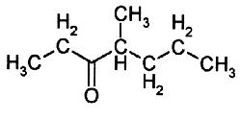

4 methyl-3-heptanone

Only 0.2 -34 micrograms (μg) are stored in the mandibular gland. Workers responding to such minimal quantities (10¹⁰ molecules/cm³) move towards the source of the odor. When the concentration exceeds 10 times this amount, the ants are induced into an aggressive response. The parsimony of pheromones is also evident in the powerful effects of the trail pheromone,
methyl 4-methylpyrrole-2-carboxylate, released by the leaf cutter ant, Atta texana. Tumlinson (1971) and his colleagues estimated that 1 milligram (mg) of this substance would lead a column of ants three times around the world!
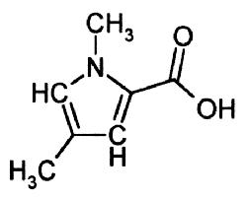

Methyl 4-methylpyrrole-2-carboxylate

Ants are unbeknownst to themselves masters of physical and organic chemistry. Their synthesized pheromones are designed for volatility, rapid diffusion, least expense of synthesis, and a variety of recognizable odors. Most pheromones contain between 5 to 20 carbons ostensibly because with fewer than 5 carbons, the variety of odors possible is too restrictive for effective communication. Molecular weights above 300 daltons are less volatile, energetically expensive to synthesize, and difficult to transport across biological membranes. There would appear to be no distinct advantage in diversity, confirmed best by ant species seldom exceeding 20 different pheromones.
From a biological perspective, there is method to the madness for pheromone design. Consider the pheromones released by the Dufour's Gland for trails of the fire ant, Solenopsis saevissima. Wilson (1962) determined that the chemical trails of this species lasts an average of 104 seconds. Bossert and Wilson (1963) then drew several implications for such rapid fade-out. An ant's gland capacity is limited, thus a small amount of pheromone is expected to be released on a trail over long distances. The active space shaped as a vapor "tunnel" should be restricted in width to maintain the integrity of the trail, and the ants should be capable of detecting a concentration gradient to stay near the center of the trail. Finally, the trail pheromones must fade rapidly to avoid over response and confusion at trail crossovers.

V. Alphabet of the Ants
Terpenoids, aldehydes, pyrazines, oleic acid, alcohols, and ketones are all common letters in the alphabet of ants. This alphabet of organic compounds allows for elaborate forms of communication among the ants. Some of the compounds are unique to some species whereas others may be shared by many throughout the ant world. The behavior elicited by a compound can be universal among species, or species-specific.
The terpenoids are commonly known as the essential oils, C₁₀ to C₁₅ compounds found in a variety of plants such as cloves, roses, peppermint, camphor, cedar, and eucalyptus. Turpentine is a familiar terpenoid. All can be considered by-products of the building block 2-methyl-1,3-butadiene, also known as isoprene.
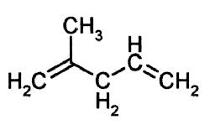

Isoprene

Several terpenoids act as alarm pheromones. In the formicine ant, Acanthomyops claviger, citral and citronellal are secretions from the mandibular gland. Examining the structures below of citral and citronellal show they are aldehyde terpenoids. Citral, also known as geranial, has a molecular weight of 172 daltons. Citronellal is similar except for a single C-C bond near the aldehyde functional group.

Citral Citronellal

Concentrations of these molecules are moderate, in the range of 10⁹ to 10¹² molecules/cm³ and indicate a moderate Q/K value of 10³ to 10⁴. A related terpenoid, limonene (oil of lemon), is also used for alarm in some species.
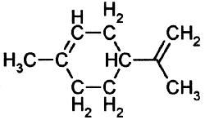

Limonene

In certain instances the blending of pheromones into mixtures determines the optimal behavioral response. A remarkable example is the pyrazine blends laid along the trails of the species Tetramorium caespitum . Two pyrazines, designated VIII and X, are produced by the poison gland. The work of Attygalle and Morgan (1983) has shown that an VIII / X ratio of 3:7 produces the optimum response to the trail pheromones. Other ratios yield responses but not with the same efficacy.
Along the same idea, a sibling species of T. caespitum, Tetramorium impurum, produces a smaller ratio of C₁₃ to C₁₇ linear hydrocarbons than does T. caespitum, but produces a higher prevalence of n-pentadecane and a sesquiterpenoid (C₁₅) compound. Also, another related species, T. semilaeve, produces an even smaller quantity of the hydrocarbons, but with even more of the n-pentadecane present. There is much speculation of cause of this gradient among these related species. One possible reason could relate to the very process of evolution where minor differences in variation yield subtle adaptive advantages. Also, blending of pheromones would allow for multiple and simultaneous signals when released from a specific gland. Blending may also allow for an increase in specificity to distinguish species and thus provide "privacy” in communication. An excellent example is shown by two species of leaf cutter ants, both of whom produce or respond to methyl 4-methylpyrrole-2-carboxylate, but only one of which uses 3-ethyl-2,5-dimethylpyrazine as its major trail pheromone.

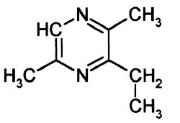

3 ethyl-2,5-dimethylpyrazine

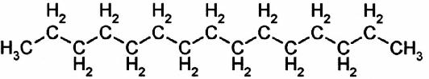

n-pentadecane

Acetates of the slave-making ants Formica subintegra are used during raids on other colonies. Approximately 700 μg of a mixture of decyl, dodecyl, and tetradecyl acetates are contained in the Dufour's gland and sprayed at defending colonies to act as "propaganda," attracting the workers of the other ant species that will eventually be enslaved. Acetates have a higher molecular weight and evaporate at a slower rate, thus acting over a longer period of time, and possibly requiring a lower response threshold. Another acetate secreted by the mandibular gland, methyl 6-methylsalicylate, is implicated in the nuptial flights and mating of the carpenter ant, Camponotus.
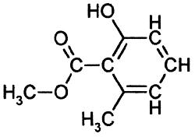

methyl 6-methylsalicylate

Oleic acid is a product of decomposition in dead insects. This fatty acid elicits corpse removal behavior, and when experimentally dabbed on living individuals causes the coerced expulsion of these healthy ants.

Oleic acid H₃C[CH₂]₇CH=CH[CH₂]₇COOH

One of the more well known carboxylic acids produced in the poison gland of formicine ants and used primarily in defense is formic acid. Birds occasionally perform an "anting" behavior which involves crushing the ants in their bills, then rubbing them through their feathers supposedly to control mallophagan lice. The formicine ants represent about 10% of all ant species and their estimated 100 trillion individuals may produce on a global basis as much as ten billion (10¹³) kilograms of atmospheric formic acid each year.
Other carboxylic acids known to be produced by ants serve as trail pheromones and include decanoic, hexanoic, and octanoic acid.
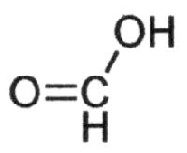
Formic acid

Multiple pheromone messages released from a single point are the result of varying active spaces and the ability of ants to respond behaviorally in sequence with the arriving pheromone vapor. In the African ant, Myrmicaria eumeniodes, a drop of poison gland secretion is placed near a prey item . The droplet contains monoterpene hydrocarbons of β-pinene, β-myrcene, and limonene. β-pinene yields a larger active space, resulting in individuals moving towards the prey. Limonene evokes a circling behavior such that the prey is approached from all sides (Bradshaw and Howse, 1984). Similarly in the African weaver ant, Oecophylla longinoda, the mandibular gland secretion produces a sequential behavior based on four pheromones. Initially, hexanal causes an alert response, followed by an attraction response of 1-hexanol. As the ant gets closer to the droplet, 3-undecanone initiates further attraction and biting, and 2-butyl-2-octenal stimulates more pronounced biting behavior (Bradshaw et.al., 1975, 1979).

1-hexanol 3-undecanone
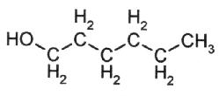
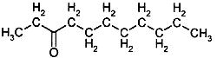

VI. Summary
In the ant world, pheromones play a large role in virtually all behaviors. Pheromone efficiency for regulating behavior is apparent when one considers that many pheromones are the result of biological convergence, that is, they have appeared independently in diverse taxonomic groups. Interestingly, similar pheromones occur in other social insects such as bees and termites, often but not exclusively for the same behavioral response. Biosynthetic pathways of pheromones must include similar physiologies in such diverse groups; nevertheless the behavioral responses in these groups must have coevolved with the pheromone to adapt each species' behavior to its habitat. Societies of living organisms must communicate to act as one, and the pheromones allow the ants to talk so well.

Bibliography and Literature Cited
Attygalle, A. B. and E. D. Morgan. 1983. Trail pheromone of the ant Tetramorium caespitum L. Naturwissenschaften, 70 (7): 365-365.

Bossert, William H. and Edward O. Wilson. 1963. The analysis of olfactory communication among animals. J. Theoretical Biology 5: 443-469.

Bradshaw, J. W. S., and P. E. Howse. 1984. Sociochemicals of ants. In W. J. Bell and R. T. Cardé, eds., Chemical ecology of insects, pp 429-473. Chapman and Hall, London.

Bradshaw, J. W. S., R. Baker, and P. E. Howse. 1975. Multicomponent alarm pheromones of the weaver ant. Nature, 258: 230-231.

Bradshaw, J. W. S., R. Baker, and P. E. Howse. 1979. Multicomponent alarm pheromones in the mandibular glands of major workers of the African weaver ant, Oecophylla longinoda. Physiological Entomology, 4 (1) 15-25.

Hölldobler, B., and E. O. Wilson. 1994. Journey to the Ants: A story of scientific exploration. Belknap Press of Harvard University Press, Cambridge, MA.

Hölldobler, B., and E. O. Wilson. 1990. The Ants. Belknap Press of Harvard University Press, Cambridge, MA.

Hölldobler, B., and E. O. Wilson. 2008. The Superorganism: The Beauty, Elegance, and Strangeness of Insect Societies. W.W. Norton & Co.

Tumlinson, J. H., R. M. Silverstein, J. C. Moser, R. G. Brownlee, and J. M. Ruth. 1971. Identification of the trail pheromone of a leaf-cutting ant, Atta texana. Nature, 234:348-349.

Wilson, Edward O. 1962. Chemical communication among workers of the fire ant Solenopsis saevissima, 2: An information analysis of the odour trail. Animal Behavior 10: 148-158.

