How to Write a Good Hook

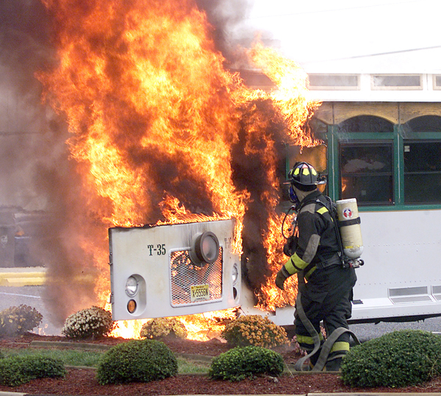

Question
- Could someone still be alive in there? Jack stared into the shadowy fire.

Humorous—hyperbole
- You could really toast some marshmallows on those flames.

Character quote
- “Get back!” Mark yelled. “It’s going to explode!”

Action, thoughts, feeling, sounds
- Brave. Jack considered himself brave, but you never really know until you are put to the test.

