AP Physics Problem
Brockport High School NY USA

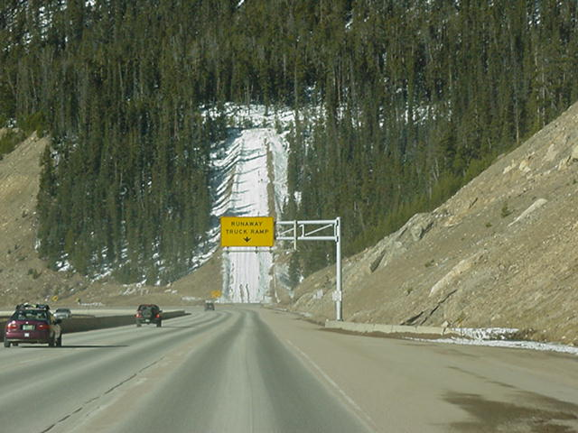
Physics Problem
The Runaway Truck

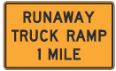
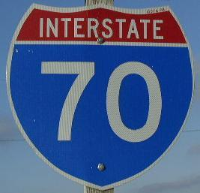
A 20000 kg runaway truck on Interstate 70 near Dillon CO enters a RUNAWAY TRUCK RAMP covered with gravel at a horizontal speed of 25 m/s. The truck is slowed to a stop in 30.0 meters after climbing a vertical distance of 15.0 meters. Determine the coefficient of friction, µ, of the gravel surface.

