AP Physics Lab Brockport High School NY USA
Emf E and Internal Resistance r Mr Keefer

Introduction
A device which can maintain different levels of electrical potential (voltage) across its terminals is said to be a source of electromotive force or emf, E. In Figure 1 below, terminals a and b are connected to an external circuit with a resistor R. When the emf source is turned on, positive charge is driven around the circuit from point a to point b through the resistor R. Real voltage sources such as batteries, have an internal resistance (r) which causes the external terminal potential difference, V_{ab}, to be less than the emf supplied by the source.
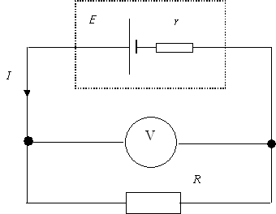

Figure 1

For the current flowing in the circuit in Figure 1, Ohm's Law and Kirchhoff's Rules give the relation between emf E and current I as

E = IR + Ir Eq. 1

Since Ohm’s Law states that V_{ab} = IR, the terminal potential difference is

V_{ab} = E - Ir Eq. 2

This is the equation for a straight line. If V_{ab} is plotted against I, the slope of the line is -r and the intercept is E . The current in the circuit can then be determined as

I = E/(R + r) Eq. 3

In this experiment you will plot the terminal voltage V_{ab} as a function of current I for the circuit above. From this plot you can determine the emf E and the internal resistance r for your power source.

Materials: power source, ammeter, 1MΩ resistor, several resistors between 10-100Ω, two multimeters, resistor color code chart, wire
Procedures
I. Determining the internal resistance of a voltmeter.
1. Set the voltage of the source (V_{s}) at exactly 10.0 V using the multimeter.
2. Select a 1M resistor and verify its value using the color code.
3. Assemble the circuit shown in Figure 2 below.

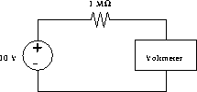

Figure 2

4. Record the voltage measured by the multimeter (V_{m})
5. Calculate the current in the circuit using Equation 4.

Equation 4 I = (V_{s} - V_{m})/R

6. Determine the internal resistance (R) of the multimeter
using Equation 5.

Equation 5 R_{m} = V_{m}/I

II. Internal resistance of a source
1. Use the voltmeter connected directly to the source’s output terminals (red and black) to adjust the voltage to exactly 5.0 volts. Set up the circuit as shown in Figure 1 above such that the voltmeter reads V_{ab} and an ammeter reads the current I through the resistor R. Be careful of the polarity of the meters.
2. Set up a data table to record the known value of R from the color chart, the voltage V read off the voltmeter, and currect I read off the ammeter.
3. Place one resistor in the circuit such that the current is less than 0.5 amps. Record the resistance and measure V_{ab} and I.
4. Replace the resistor with another and repeat step 3 for four other resistors.

Analysis
1. Plot V_{ab} vs I (x-axis).
2. Determine from the graph the internal resistance r of the source and E .
3. Determine the maximum current for your circuit.
4. How should ammeters and voltmeters be connected in a circuit for proper readings?
5. What happens to internal resistance as a source produces more current? What happens to the external voltage (V_{ab}) as more current is produced? Why does a new 1.5 volt AA battery yield a reading of about 1.60 Volts when not in a circuit?
6. Discuss the misnomer “electromotive force.”

