Name _______________________________________________ Brockport High School Physics

Examine carefully the combination of graphs on the next page representing a ball initially in free fall, then bouncing on the floor several times.

1. On each of the graphs, label the location of the following:
a) the first and second bounces
b) the top of the flight after the first bounce
c) the ball falling after the first bounce
On the velocity-time graph, label:
d) the slopes representing the acceleration of gravity
e) the slopes representing the acceleration during the bounce
f) the loss in velocity between the first and second bounce.
g) the elapsed time between the first and second bounce.

2a. Use the slope on the v-t graph between 1.6s and 2.1s to calculate the acceleration of gravity. Use caution with the +/- velocities. Calculate a percent error.
2b. Calculate the acceleration of the second bounce. Use caution with the +/- velocities. Compare with the acceleration of gravity.

3. What happens to the elapsed time between successive bounces? Explain.
4. What happens to the velocity after each bounce?
5. What happens to the acceleration of gravity after each bounce? What evidence can you give for your answer?

6. Using the distance of fall and elapsed time from the initial drop (shown on the distance-time graph), calculate and compare the acceleration of gravity using the equation:
d = ½ gt²

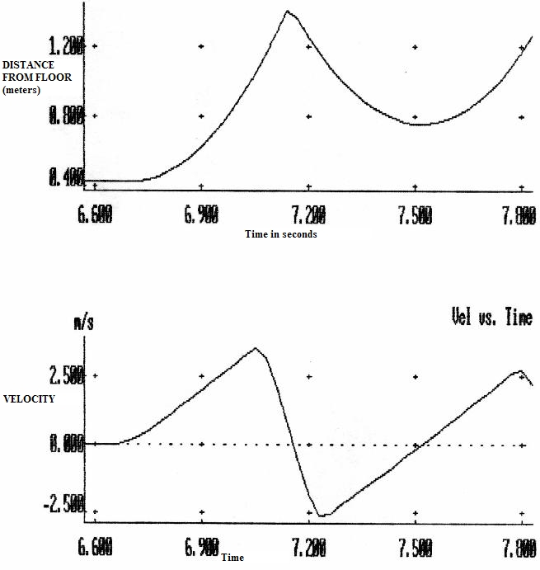
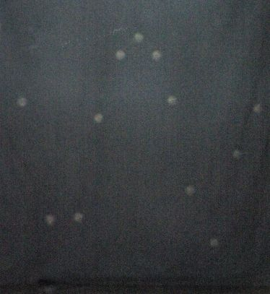
Strobe of a bouncing steel ball. Try to match the motion in the photo with the graphs above for a true understanding of this assignment.

